**ME 755 Senior Design**

**Fall 2017**

**Analyses**

**Team 13**

**Project Name:** SEDS Rocket and Static Test Fire Rig Analysis

**Team Members:** Reilly Webb

Nicholas Clegg

Keven Bucher

**Project Sponsor:** Contact name (name of faculty if project sponsored by a faculty member)

Contact email

Company name (“UNH” if faculty)

**Faculty Advisor:** Todd Gross

Introduction

To successfully launch a two-stage, solid propellant rocket to the highest possible altitude, UNH SEDS must perform a multitude of analyses of varying complexity. The engineering team focuses on five major aspects of design. Two of the largest divisions are the static test fire rig team and the aerodynamics team. The following discussion will explain the problem-solving methods and analysis that each team has been implementing and what the future holds for each of the designs.

The first iteration of the design will be a single stage rocket. This single stage design will be launched many times before starting the design on the two-stage rocket to have sufficient confidence in experimental methods and to have a solid foundation of data in our test bed for comparison to our theoretical results. The following analysis is done for the design of this initial single stage rocket.

**Static Test Fire**

Statement of Analysis

The static test fire rig is used for the sole reason of recovering thrust from the engine of our choosing. The test fire rig design will be used first for a 29 mm solid rocket engine, and then afterwards for the future testing of larger diameter engines. After knowing a range of thrust our engine will produce, we can then implement the required gauge to calculate thrust. Knowing the performance of the engine will help us estimate the maximum altitude of the rocket.

The team will be using a 250 lb load cell for an approximated 300 N of thrust.  There are many benefits to a load cell, primarily that there is no calibration required, and setup and implementation is simple. In order to obtain thrust we will need to understand the inner workings of the load cell.  The load cell consists of 4 strain gauges in a Wheatstone bridge configuration. Two of the strain gauges are in tension while the other two are in compression creating a change in resistance that produces a change in voltage output. Our goal is to convert the given voltage to thrust using a given sensitivity.

Diagram

    The following figure is a rough representation of the static test fire rig setup.

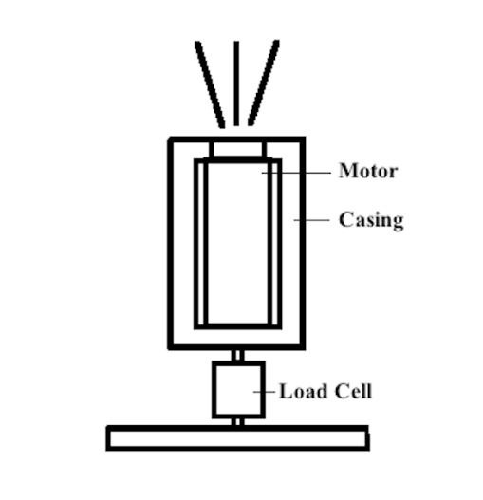

*Figure 1: Static Test Fire Rig*

The rocket motor will be tightly secured inside of a cylindrical casing that will have an inside diameter of 54 mm. The test fire rig will be used for testing various motor diameters for multiple rocket projects. For our first analysis, a 29 mm motor will be analyzed. The load cell will screw into both the steel base plate and steel casing assembly. Set screws may be utilized to provide tighter motor fitment and discourage movement inside the casing. The engine will ignite, expel exhaust gases upwards, and result in a downward force on the load cell. In conjunction with LabView, the load cell will record voltage and time data.

Assumptions

For the analysis, the assumption will be made that the force of the rocket is only in the vertical direction, with no horizontal dependence considered.  The sensitivity of the given load cell is assumed to be exact. We are assuming the force on the bottom casing will be fully recovered by the load cell placed beneath

Governing Equations and Calculations

The force that the engine will apply on the load cell will be expressed as *F = ma*. Where F is force, m is the mass of the motor, and a is the acceleration of the motor. The output given by the load cell will be in voltage and can be converted to force. The resulting thrust response will be found as a function of time. The sensitivity is 3.4 mV/V at full scale. With an excitation voltage of 10 V we will receive 34 mV output for a 250 lb input, and using an amplifier with a gain of 100 the final output will be 3.4 V. We will find that there is .0136 V per pound of force. Using this relation we can convert the voltage output to thrust. After calculating thrust, the impulse of the rocket engine can also be found by the relationship: *Impulse* = *Thrust* x *Time.*

Solutions and Results

We expect to record a thrust vs time curve similar to the following figure:

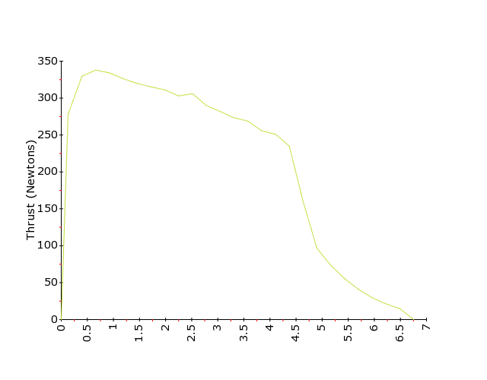

*Figure 2: Force vs Time*

As seen from the figure above, the maximum thrust of the engine will be reached well within the first second, and thrust will see a slow decrease in the consecutive seconds of the launch. This is standard response for the selected engine type being tested and experimental results are expected to be very similar. Additionally, from the measured thrust curve, the impulse of the engine can be determined as well. The rocketry competition limits total impulse at 640 N-s. Having a two-stage rocket means that the combined impulse of both engines cannot exceed this.

**Rocket Aerodynamics**

Fundamental Concepts:

**Margin of Stability**

The CG should be forward of the Center of Pressure by 1-2 diameters. More than two diameters of stability and the rocket will be "over stable". An over stable rocket will tend to turn dramatically into the wind.

**Adjusting the Center of Gravity**

To move the CG forward, weight can be added to the nose, the rocket can be extended, or weight can be lowered in the aft end of the rocket. To move the CG aft, (for example, if the rocket is over stable), do the reverse.

**Adjusting the Center of Pressure**

It is generally easier to focus on moving the CP. To move the CP aft (more stable), increase the size of the fins. To move the CP forward, decrease fin size. CP is also affected by nosecone and fuselage geometry, however, it is simpler to adjust the fin dimensions.

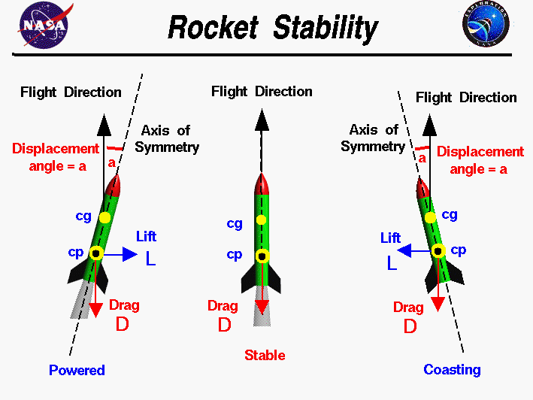

*Figure 3: Rocket Stability*

Taken from: https://spaceflightsystems.grc.nasa.gov/education/rocket/rktstab.html

The aerodynamic forces on the rocket are the result of pressure variations around the surface of the rocket. In general, you must determine the integral of the pressure times the unit normal, times the area, times the distance from a reference line. Then divide by the integral of the pressure times the unit normal, times the area.

The following assumptions can be made for simplifying the calculation of the center of pressure of a rocket of this scale:

* Geometry is symmetric about the axis of the rocket
* Surface pressure variation is insignificant.

To find a rough estimate of the location of the center of pressure, we need to find the average location of the projected area distribution.

**Simplified Calculation of CP**

The projected area and location are given, relative to the base of the rocket, for each of the major parts of the rocket: the nose, body tube, and fins. The total projected area **A** of the rocket is the sum of the projected area **a** of the components.

$$A=a_{nose}+a_{tube}+a_{fins}$$

Since the center of pressure is an average location of the projected area, we can say that the area of the whole rocket times the location of the center of pressure **cp** is equal to the sum of the projected area of each component times the distance **d** of that component from the reference location.

$$cp=\frac{(a*d)_{nose}+(a*d)_{tube}+(a*d)_{fins}}{A}$$

The location, d, of each component is the distance of each component's center of pressure from the reference line. This value, along with the calculated masses and center of gravity for each component was determined and put into the following table.

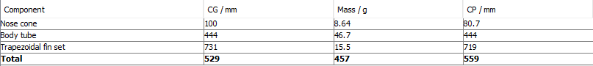

*Table 1: Stability Values*

**Flow Simulations:**

A program called OpenRocket was used to dynamically calculate the location of the center of pressure as different dimensions of the rocket components were varied for optimization purposes. The helped enforce one of the constraints of the optimization: that the center of pressure must be kept behind the center of mass by more than 1 diameter. The center of pressure estimate is also dependent on the average Mach number. For our purpose we used Mach 0.3. The calculation method for our simulations was the Extended Barrowman method, which calculates aerodynamic forces according to the Barrowman equations extended to accommodate additional components such fins. Additional information on the Barrowman equations can be found in reference [2].

Integration for the simulation is performed using a 4th order Runge-Kutta numerical integration. This integration is done for all 6 degrees of freedom during flight. A time step of 0.05 was used, as the resulting convergence was satisfactory at this value.

Geodetic calculations for the simulation are performed assuming a perfectly spherical earth. The average cross-wind speed during the simulated flight set at 2 m/s, with a standard deviation of 0.2 m/s and a turbulence intensity of 10% of the average windspeed. Standard temperature and pressure was assumed for the launch site.

Fuselage:

The following dimensions are driven by the geometry of the engine that we are using: A Pro29 381I224-15 engine manufactured by Cesaroni Technology. This engine was chosen as its total impulse is about 380 Ns and the competition limits total impulse to 640 Ns (the final multistage design will have two of these engines). 29 mm inner diameter engine casing will be press fitted into a cylindrical fuselage. Therefore, the inner diameter of the fuselage will be about 29.05 mm. The thickness of the carbon fiber sheet is dictated by the required rigidity to wrap around the engine casing. This thickness is about 0.5 mm depending on the grade of carbon fiber that we decide to use. Therefore, the outer diameter of the fuselage will be about 30.05 mm.

The rocket engine will have an overhang of 1.27 cm from the end of the rocket. The ideal length of the rocket without considering any other components would be the exact length of the engine, which is 36.5 cm minus a 1.27 cm overhang resulting in a 35.23 cm fuselage. However, space for the parachute, altimeter, and other internal systems must be considered. The minimum safe required volume for these components is about 140 cubic centimeters. The additional fuselage length required to satisfy this volume is found as follows:

$$L_{sys}=\frac{V}{π(r)^{2}}=\frac{140 cm^{3}}{π(1.45 cm^{2})^{2}}=21.196 cm$$

$$L_{fuselage}=L_{engine}+L_{sys}=56.426 cm$$

The fuselage is now fully defined, so it can be treated as a constraint in the optimization of the remaining components. The ideal nose cone geometry is dependent on the average speed of the rocket, and is found experimentally.

Nose Cone:

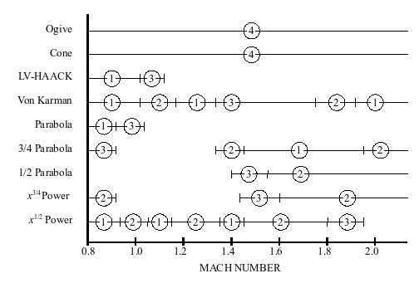

*Figure 4: Experimental Nose Cone Data [3]*

For our purpose, the Von Karman shape is the optimal design. The Von Karman geometry is defined by a line that is revolved about the axis of the rocket. This line is defined by the following equation known as the Haack Series:

$$θ=\arccos\left(1-\frac{2x}{L}\right)$$

$$y=\frac{R}{\sqrt{π}}\sqrt{θ-\frac{\sin\left(2θ\right)}{2}+C\sin^{3}{θ}}$$

The Hack series defines the minimum drag line equation for a given length, L, and radius, R. For the Von Karman shape that we are using, C=0. R is given as the internal radius of the fuselage (29.05 mm), and x is the dependent variable that is a range of 0 to L. L is the unknown in this equation that is to be optimized.

Fins:

The last component in this analysis is the fins. The purpose of the fins is to make sure that there is sufficient passive restoring force in a crosswind so that the rocket remains stable and upright. It does this by lowering the center of pressure below the center of mass by increasing the average surface area at the lower end of the rocket.

A parallelogram was chosen as the fin shape as it is easy to manufacture consistently and has a high lift coefficient and low drag. Only 3 equally spaced fins are necessary to provide necessary restoring force and to keep drag at a minimum. Thickness is determined by the thickness of the material that we are using. As of now it is 2 mm fiber glass. The optimal position for the fins is right at the from the end of the fuselage with no overhang. This is the best position for influencing the center of pressure as well as maintaining the structural integrity of the fins. Fin height, root chord, tip chord, and sweep angle must all be determined through optimization.

Optimization Results:

A few additional constraints will be applied to the optimization. This includes a minimum root chord of 5 cm in order to maintain fin integrity (especially during landing), as well as a stability range of 1-2 diameters. A mass 15 g was also added right under the nosecone to simulate the effective mass of the parachute and other systems.

The goal of the optimization is to maximize apogee altitude. This is done by balancing the thrust to weight ratio of the rocket with the required aerodynamic restoring forces for the expected cross windspeed.

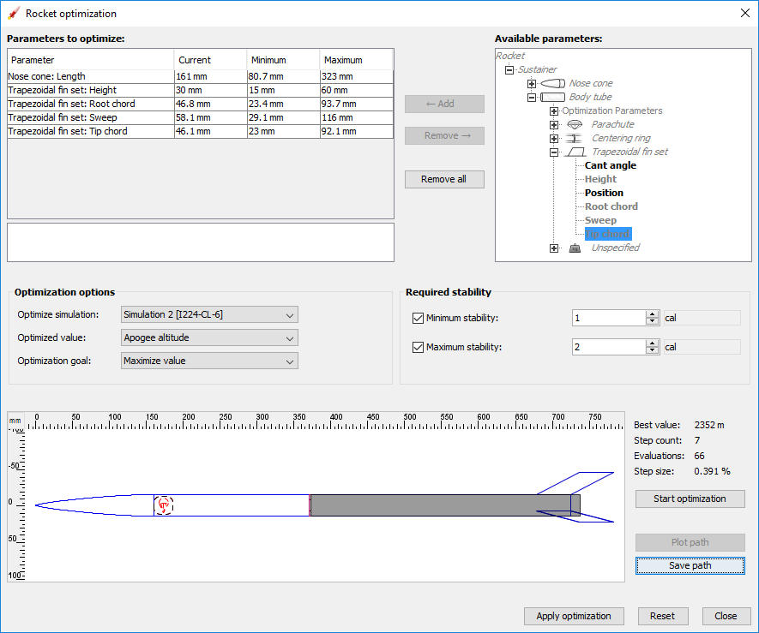

*Figure 5: Optimization Results*

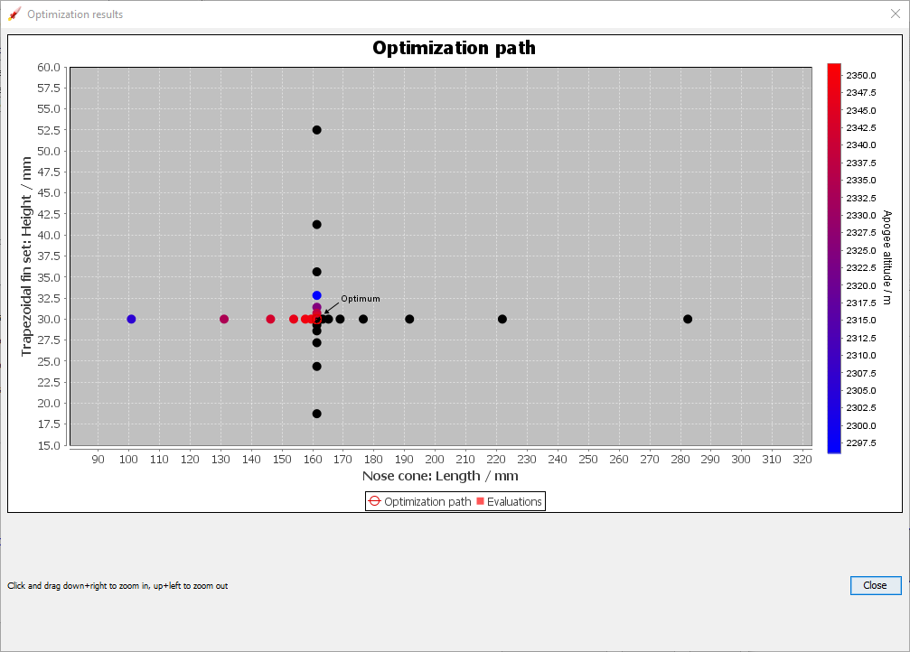

*Figure 6: Optimization Convergence Example*

A motion simulation could then be performed using engine data and the optimized rocket design.

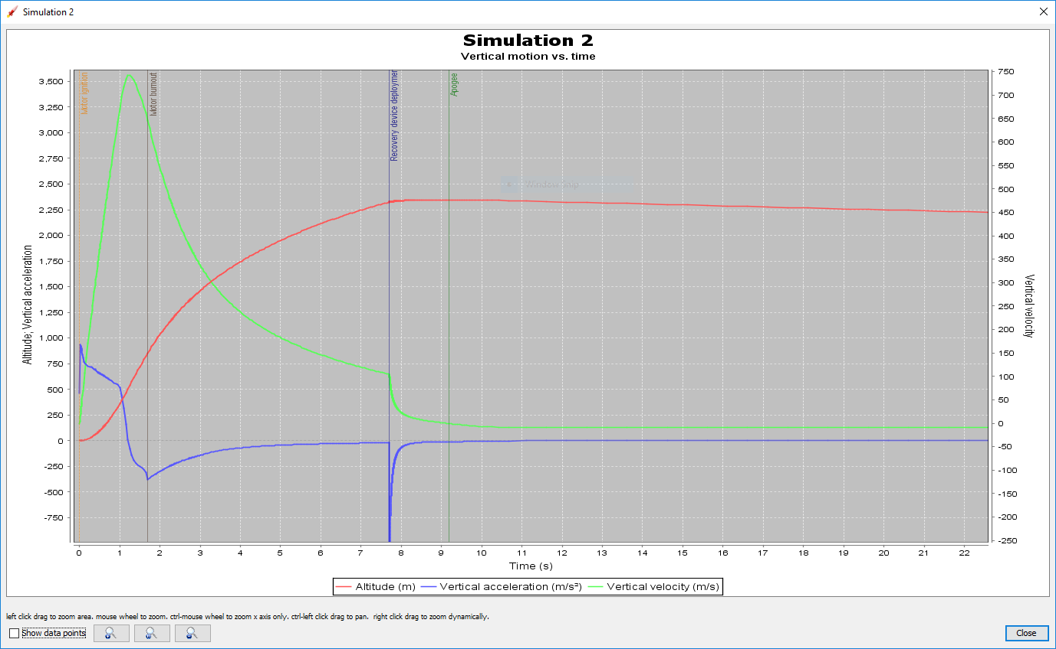

*Figure 7: Complete Motion Simulation*

*Table 2: Resultant Drag Force Data*



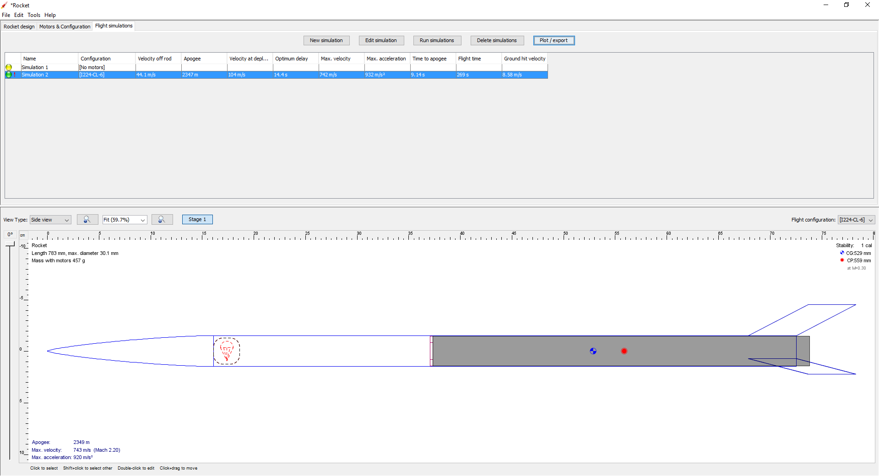

*Figure 8: Final Design*

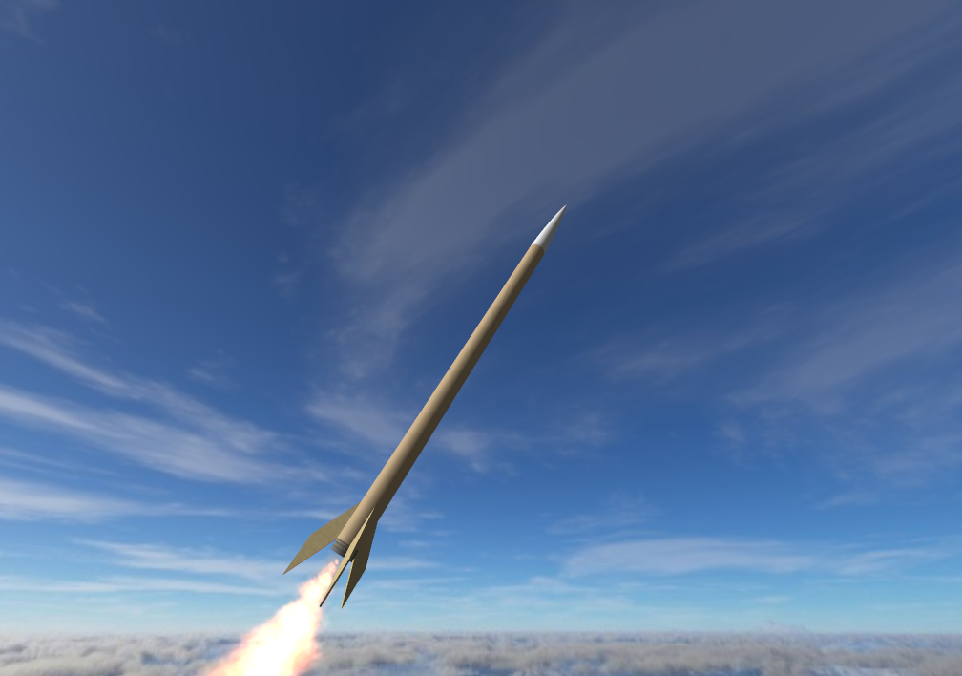

References:

Department of Defense Military Design Handbook (1990). Design of Aerodynamically Stabilized Free Rockets. MIL-HDBK-762(MI).[[1]](http://www.everyspec.com/MIL-HDBK/MIL-HDBK-0700-0799/MIL_HDBK_762_1855/)

<http://www.rocketmime.com/rockets/Barrowman.html>. [2]

Crowell, G. A. (1996). The Descriptive Geometry of Nose Cones. Retrieved from <https://web.archive.org/web/20110411143013/http://www.if.sc.usp.br/~projetosulfos/artigos/NoseCone_EQN2.PDF> [3]